# Brand New UI. Now work as App Indicator

# OpenFreezeCenter

- This project will be weekly Updated!

- For more features do comment and share your views!

- Well if you like my work, Do follow me for more awesome projects!!

For Those running Linux Distro on MSI laptops. This is the Graphic User Interface application meant for Fan control and monitoring in Linux.

- This Application can run on any Linux distro!!

- Installation is very easy with one command solution!!

### Disable SECURE BOOT because it interferes with the permission of the script to read/write to EC file.

# DELETE PREVIOUS FOLDER FOR THIS APP AND WORK WITH NEW ONE!

# SUDO PERMISSIONS REQUIRED FOR CHANGING FAN MODES, MONITERING, EC MAP, BATTERY THRESHOLD

# How To Install GUI app?

- Download the .zip from the github and extract it wherever you want

- Open terminal inside the extracted folder and run ```./at_startup.sh```

- This will install all the dependencies which are missing and open the GUI app for the first time.

- App will create a ```conf.txt``` file. it will contain all your configurations and fan curve values. deleting that file will reset all your fan curves.

# For any issue and query comment!

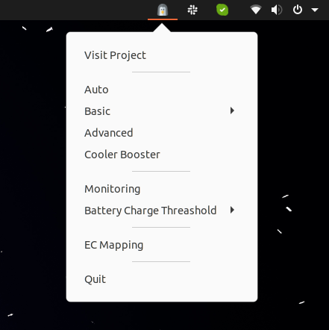

# Screenshots

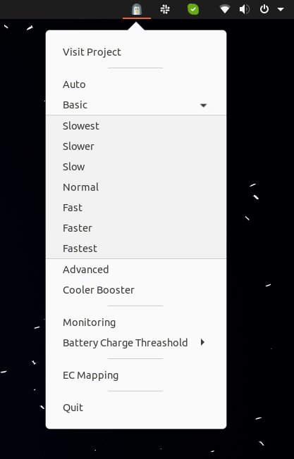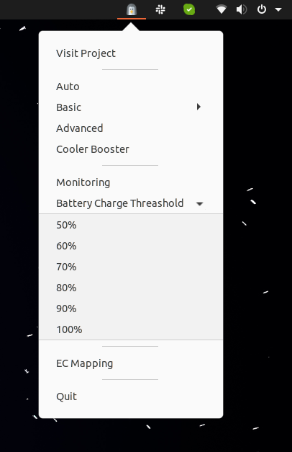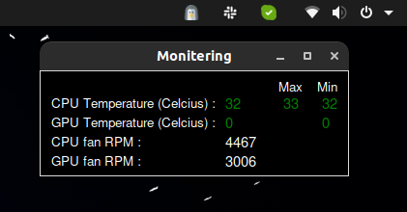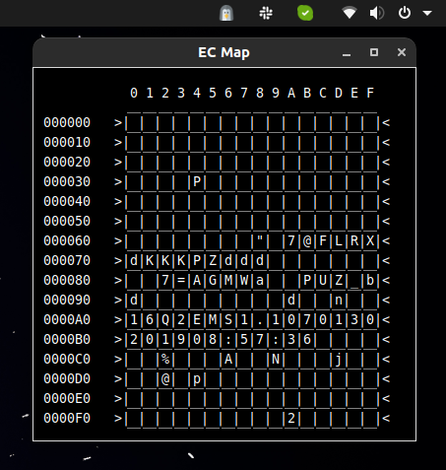

# Working on models

- MSI GE66

- MSI GS65

- MSI GF63

- HELP ME ADD MORE MODELS. TEST AND REPORT ME

# Goals

```

- Basic GUI Done

- Fan Control with GUI Done

- Auto, Basic, Advanced, Cooler Booster Done

- Basic temperature and RPM monitoring Done

- One click install Done

- Dark Mode Done

- Configuration file Done

- Back version support Done

- Making Pre-required installs automatic Done

- Integrating it as an app indicator Done

- EC Map View Done

- Graph to monitor Temps and speeds In beta Testing

```

# Known Bugs :- 0